### Southern New Hampshire University

### CS 319 – UI/UX Design and Development

### Module 7-1: Project Two

Kenneth Wilkerson

### Dr. Vivian Lyon

August 18, 2024

**Borrower Embedded Digital Wireframe**

**Screen 1:**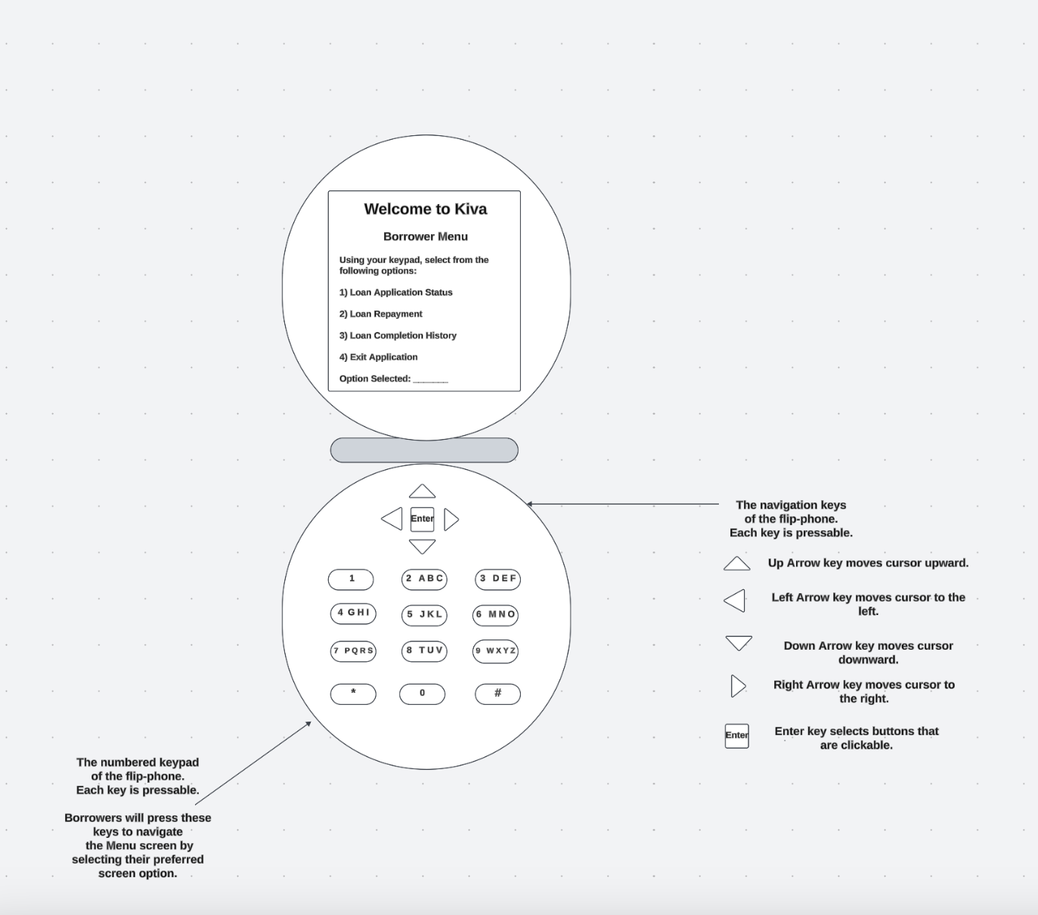

**Screen 2:**

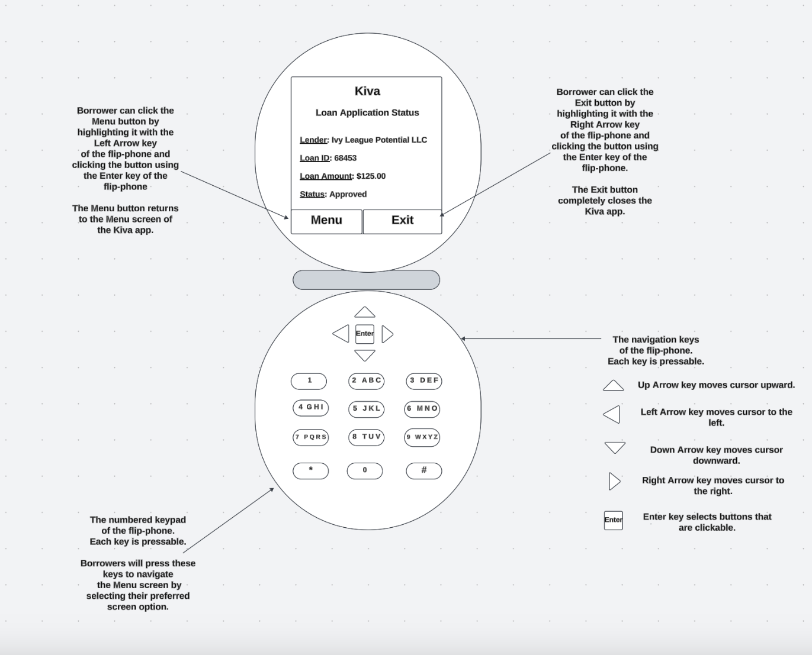

**Screen 3:**

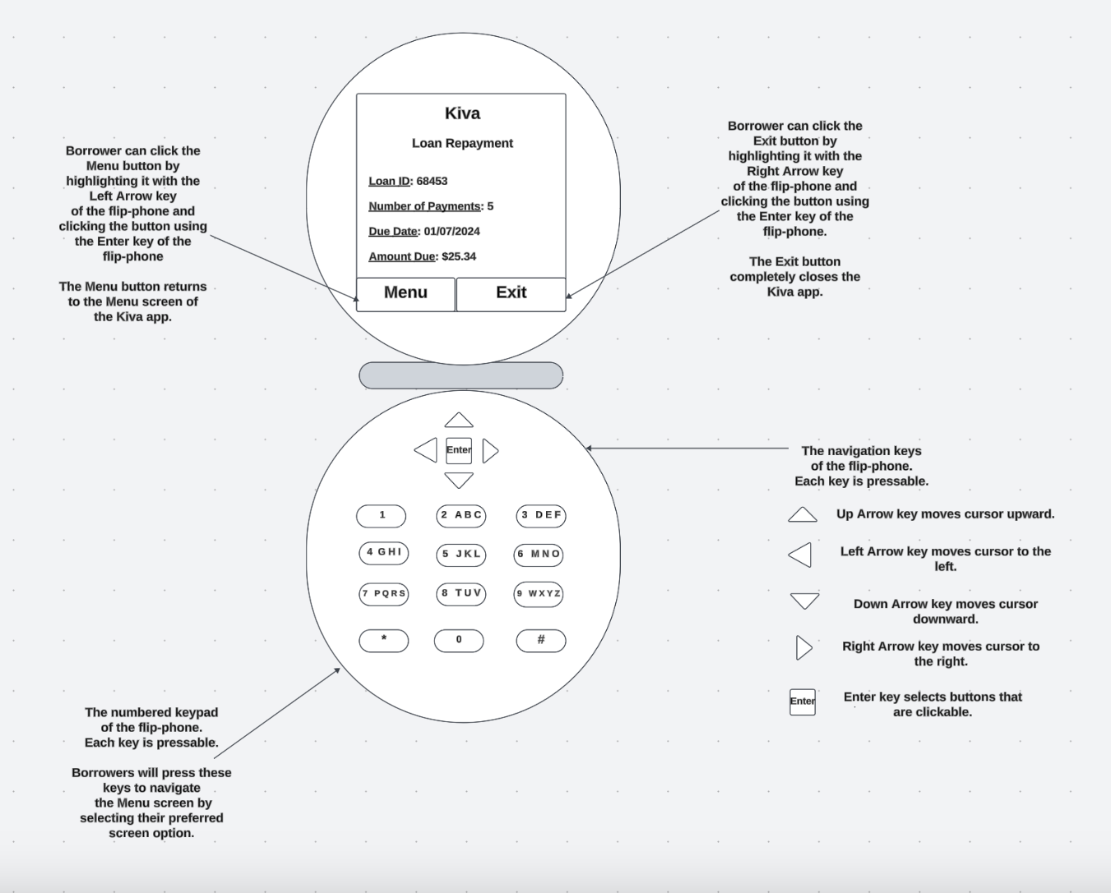

**Screen 4:**

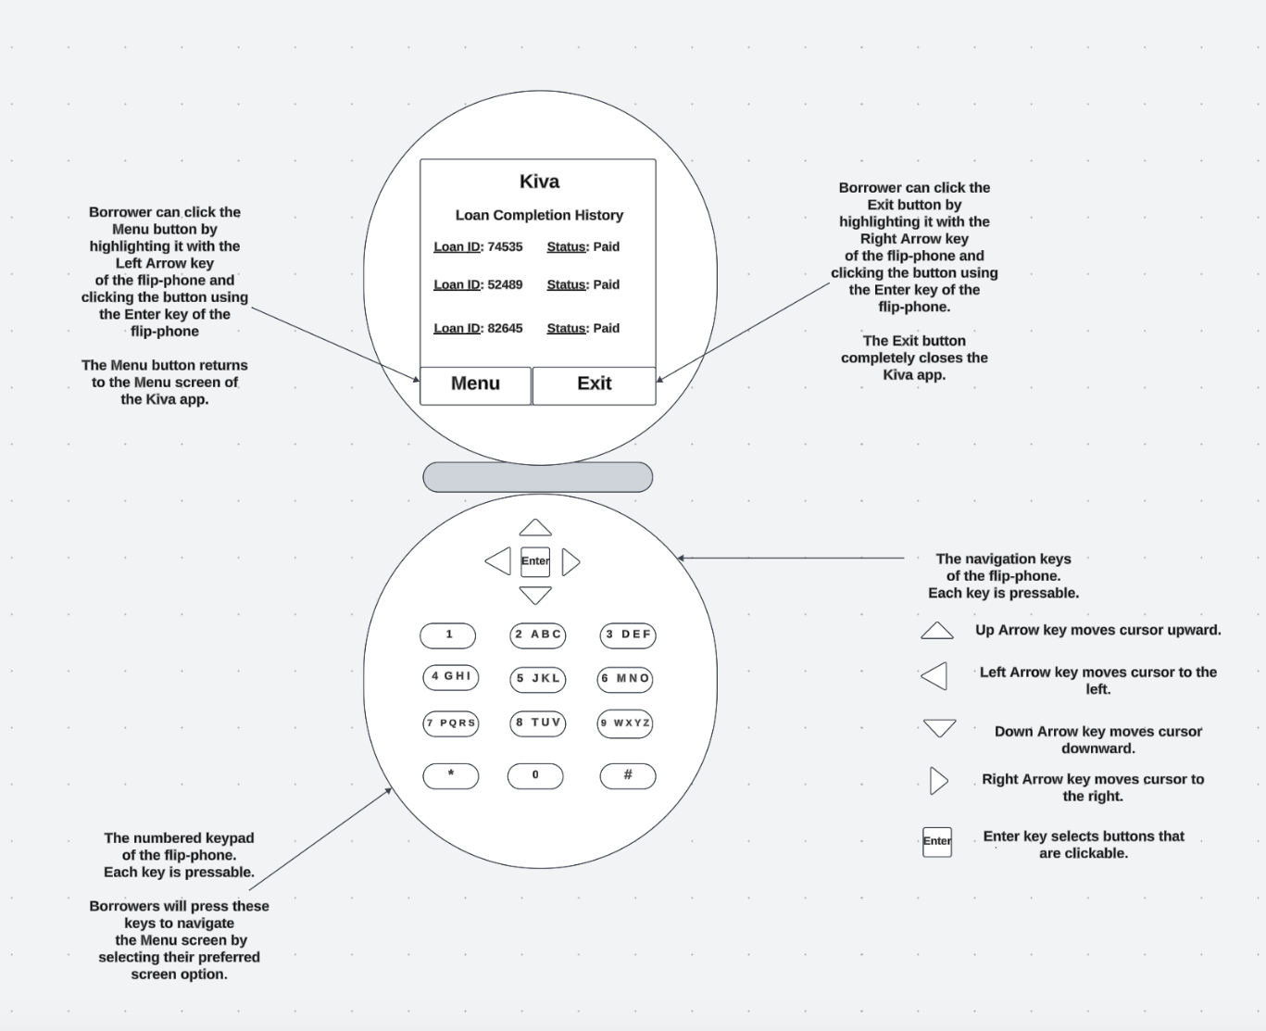

**Rationale**

The Borrower Menu screen is designed for the borrower to utilize a numbered menu where they can navigate using the keypad of a flip-phone. At the top of the screen, there is a header that welcomes borrowers to the application. There is also a header that outlines the purpose of the screen which is to let borrowers know they are currently at the Borrower Menu screen. There are instructions included on this screen to guide user navigation. There are four numbered options the borrower has to choose from. First, borrowers can press number one on their flip-phone to access the Loan Application Status screen. When borrowers press number two on their flip-phone, they will access the Loan Repayment screen. Furthermore, when borrowers press number three on their flip-phone, they will access the Loan Completion History screen. Lastly, when borrowers press number four on their flip-phone, they will exit the Kiva application. As the borrower presses a number, there will be a ding sound and a brief vibration to provide confirmation to the borrower to indicate that they are moving to a new screen.

The Loan Application Status screen lets borrowers know the status of loans they have applied for using the Kiva app. The Kiva organization name is located at the top of the screen. There is also a header to let borrowers know that they are currently on the Loan Application status screen. This screen includes four labels based on four important fields that are included to provide the borrower with up to date information on the borrowers’ loan application. First, the Lender field provides the name of the institution that is offering the loan. This is followed by the Loan ID field which provides an identification number that all other loan information is associated with. Furthermore, there is a Loan Amount field which shows the borrower the full amount of the loan. Lastly, there is a Status field which indicates if the loan has been approved or not. At the bottom of the screen, there are two clickable buttons that borrowers can use to navigate through the app. On the left side, there is a clickable Menu button. Borrowers need to highlight the button first using the Left Arrow key on the flip-phone for navigation. This button will turn blue to indicate that it has been highlighted. The borrower will then need to hit the Enter key on the flip-phone for navigation. Once this button has been clicked, a click sound will follow to provide the user feedback to confirm the button has been clicked. There will also be haptic feedback in the form of a brief vibration to assist hearing impaired users. After the Menu button is clicked, the borrower will return to the Borrower Menu screen of the application. On the right side, there is a clickable Exit button. Borrowers need to highlight the button first using the Right Arrow key on the flip-phone for navigation. This button will also turn blue to indicate that it has been highlighted. The borrower will then need to hit the Enter key on the flip-phone to click the button. Once this button has been clicked, a click sound and brief vibration will follow the action to provide the user confirmation that the button has been clicked. After the Exit button is clicked, the borrower will exit the Kiva application.

The Loan Repayment screen provides an overview of the loan terms and information for upcoming payments that are due. The Kiva organization name is at the top of the screen. There is also a header that outlines the purpose of the screen which is to let users know that they are currently on the Loan Repayment screen. This screen includes four labels based on four important fields that are included to provide the borrower with up to date information on the borrowers’ loan repayment information. First, the Loan ID field is used to identify the borrowers’ loan. This is followed by the Number of Payments field which indicates how many payments are remaining on the borrowers’ loan. Furthermore, the Due Date field provides the exact date of the next payment that is due from the borrower. Lastly, the Amount Due field shows the exact payment amount that the borrower is responsible for. At the bottom of the screen, there are two clickable buttons that the borrower can click on for navigation. One the left side, the Menu button can clicked by the borrower by first highlighting the button using the Left Arrow key of the flip-phone. This will highlight the button in blue to let the user know the area of focus on the application. The borrower can click the button after it is highlighted by pressing the Enter key of the flip-phone. This will be followed by a click sound and a brief vibration to confirm that the borrower is returning to the Borrower Menu screen. On the right side, the Exit button can be clicked by the borrower by first highlighting the button using the Right Arrow key of the flip-phone. This will highlight the button in blue to let the user know that they are focusing on the Exit button. The borrower can click the button after it is highlighted by pressing the Enter key of the flip-phone. This will be followed by a click sound and and a brief vibration to confirm that the borrower is exiting the Kiva application.

The Loan Completion History screen shows a list of older loans that have been completed by the borrower. The Kiva organization name is at the top of the screen. There is also a header that outlines the purpose of the screen which is to let borrowers know they are currently on the Loan Completion History screen. This screen includes two fields that provide an overview of the loan history of the borrower. On each line there is a Loan ID and Status field that shows each loan the borrower has completed. There are two clickable buttons at the bottom of the screen. On the left side is the Menu button. This button can be highlighted using the Left Arrow key of the flip-phone. The button will turn blue when highlighted. Once the button is highlighted, the borrower can click the button by pressing the Enter key on the flip-phone. This will be followed by a click sound and brief vibration. This functions as confirmation to the borrower that they are returning to the Borrower Menu screen of the application. On the right side is the Exit button. This button can be highlighted using the Right Arrow key of the flip-phone. This button will also turn blue when highlighted. After highlighting the button, the borrow can click the button by pressing the Enter key on the flip-phone. This will be followed by a click sound and brief vibration that lets the borrower know that they are exiting the Kiva application.

The design of the Borrower Menu screen benefits the borrower because all of the important information in the application is connected through this screen. This ensures an accessible, efficient and user-friendly application. The design also takes into account that borrowers will be using the application from an embedded device and utilizing the number and directional keys of the flip-phone for navigation. The instructions, colored highlighting, sound and haptic feedback guide borrower interaction and provide useful feedback that allows them to have a familiar experience with the application. These features also incorporate best practices into the UI design. The Borrower Menu covers the core elements of the borrower story which is that they want to access information on requesting loans and track their loan payback process. This design also benefits Kiva by only including essential information in the application. This minimizes storage while maintaining the integrity of their organization.

The design of the Loan Application Status screen benefits the borrower because they are able to quickly apply for and track Kiva loans. There are only four fields included in the screen which allows the borrower to quickly glance at the overview on the screen and understand if they have been approved or not. The fields are clearly labeled which assists borrower comprehension. The clickable Menu and Exit buttons at the bottom of the screen are noticeable which makes it easy for borrowers to locate. This helps users quickly move on to other screens or completely exit the application. The colored highlighting, sound and haptic feedback on this screen continue to assist user navigation and provide feedback that enhances usability. This design also benefits Kiva because it allows them to be transparent regarding financial information. This helps them maintain their reputation as an organization that wants to reduce poverty.

The design of the Loan Repayment screen benefits the borrower because they are able to see what is needed for them to complete the terms of their Kiva loan. There are four fields that are included which provides an essential but quick overview of the loan payback process. The fields are also clearly labeled here to enhance borrower comprehension. The two clickable buttons (Menu and Exit) are available on this screen as well so that users can move on to other screens or exit the application. The colored highlighting, sound and haptic feedback are included on this screen for continuity. This design also benefits Kiva because providing clear information to their borrowers makes it easier for them to pay back their loans. This allows Kiva to continue to offer loans to other borrowers and expand the mission of their organization.

Lastly, the design of the Loan Completion History screen benefits borrowers because they are able to access their entire history as a borrower of Kiva loans. This allows them to find lenders that provide the best terms for them. The history screen provides evidence that they are a trustworthy borrower which will allow them to continue to receive Kiva loans in the future. There are two fields on this screen that are clearly labeled to help create a comprehensive list of loan history. The two clickable buttons (Menu and Exit) are available on this screen so that borrowers can move on to other screens or exit the application. The colored highlighting, sound and haptic feedback are included in this screen to make sure best practices and accessibility are included throughout the application. This design also benefits Kiva because it helps the organization determine which borrowers are eligible for future loans. It also helps them demonstrate the impact these loans have on borrowers’ lives over time.

Due to the constraints of the embedded device used by borrowers, a minimalist UI design was necessary for clarity and saving money. The number and directional keys of the flip-phone were utilized as navigation tools that borrowers use throughout the app. These keys provide quick and user-friendly ways to move between screens. My prior research informed me that only essential data should be included in each screen. This data should be displayed with clear labels so that users can easily understand the information that is included. Additionally, instructions, clickable action buttons, color usage through highlighting as well as sound and haptic feedback help guide user interaction and enhance the overall user experience. These features make the app easy to learn and easy to remember which builds comfort among the borrowers. Incorporating best practices was a core priority throughout the design process.

**Cloud-Based System Recommendations**

The design for embedded devices can be scaled up for usage on a cloud-based system through services such as Amazon Web Services (AWS) or Microsoft Azure. Using a cloud-based system would allow for an increased user capacity. This would expand the reach of Kiva’s mission statement which is to reduce poverty throughout the world. Borrower profiles can be expanded to include photos, biographies and the purpose of the loan so that a more human connection can be made in the app. This would help lenders make informed decisions when it comes to the approval process. More detail could be included to describe the business and community impacts that resulted from the loan. Including success stories would provide tangible information that demonstrates that the Kiva organization is taking steps to reduce poverty. There should be real time communication between the lender and borrower dashboards. Lenders should be notified when borrowers make payments on their accounts. Borrowers should receive repayment alerts and new loan opportunities though text message and email. There should be data caching to reduce repeated calls to the database which makes communication between all dashboards faster.

Lenders may have different motives when offering loans to borrowers on the Kiva app. Some lenders may offer loans because they want to create a positive social impact. For example, gender equity or improving access to clean water throughout the world are humanitarian causes that inspire people or organizations to take action. On the other hand, some lenders may be financially motivated. They might offer loans to make profits through interest rates. Overall, each lender helps to achieve the Kiva mission of reducing global poverty. A cloud-based system would expand the reach of the application and ensure that underserved communities are no longer left behind.